**Assignment Web Programming**

**Name : Mikel Vanesius Tanutomo**

**NIM : 2502040354**

**Link :**

**Routing Code**

**Controller Code**

CategoryController Code

HomeController Code

PublisherController Code

**Model Code**

BookModel Code

CategoryModel Code

PublisherModel Code

BookCategoryModel Code

**View Code**

DefaultLayout Code

HomeView Code

BookDetailView Code

CategoryView Code

PublisherView Code

PublisherDetailView Code

ContactView Code

**Migration Code**

BookMigration Code

CategoryMigration Code

PublisherMigration Code

BookCategoryMigration Code

**Factory Code**

BookFactory Code

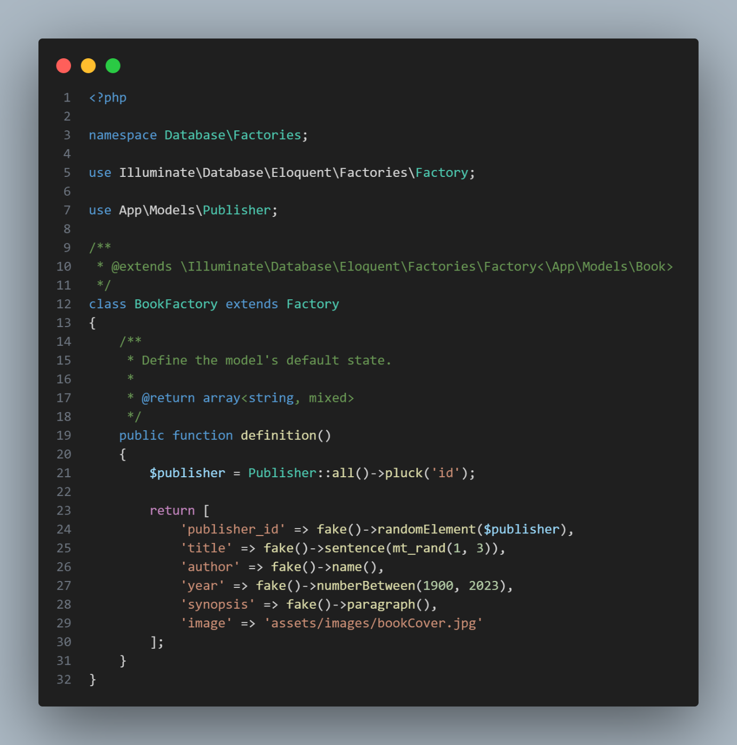

PublisherFactory Code

**Database Seeder Code**

**Page Result**

Home

BookDetail

Category

Publisher

PublisherDetail

Contact

